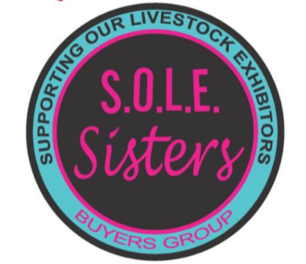**S.O.L.E. Sisters Buyers Group Donation Form**

**Please, list the items you donated to SOLE Sisters Buyers Group. (You may attach your own list.)**

**__________________________________________________________________________________________________________________________________________________________________________________________________________________________________________________________________________________________________**

**Value of items donated: ______________________________________**

**Thank you for supporting our mission!**

S.O.L.E. Sisters Buyers Group supports the livestock exhibitors of Fort Bend County that show at the county fair. S.O.L.E. Sisters Buyers Group is a registered 501(c) (3) organization. EIN: 85-1023307

**Name: ____________________________________________________________**

**Address: __________________________________________________________**

**City: _______________________________State/Zip: ______________________**

**Save this receipt for tax purposes.**

**This receipt is the only record of your tax-deductible donation. No goods or services were provided to the donor by SOLE Sisters in exchange for the donation.**

**SOLE Sister Record**

**SOLE SISTER: ______________________________________________________**

**Date: _____________________**